Azure Data Factory Notes

- Data factory is fully manage serverless data integration solution for ingesting, preparing and transforming all your data at scale.

- Data Factory provides the ability to ingest data from all of those sources we just mentioned. It provides connectors to 90 plus sources, and it's increasing.

- Just to give you an idea, there are connectors for SAS applications such as Salesforce and Office 365.

- Basically, Data Factory provides an end to end solution for our data integration transformation and orchestration needs.

Project Overview
The project that we are going to develop during this course is based
around reporting and prediction of COVID-19 spread.
Firstly, we want to create a data platform from which our data science team
can run machine learning models to predict the spread of the virus, and find other insights from the data.
Secondly, we wanna create a data platform from which our data analysts can easily report
on the COVID-19 trends using a reporting tool.
So, those are the two main objectives of our project. The solution that we are building will be limited to reporting on the data related to EU countries and UK only.

Solution Architecture of Project

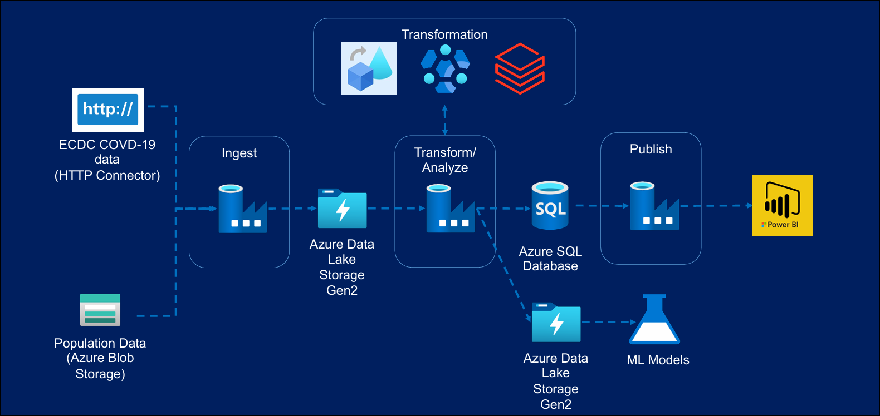

Key points:
- Use http connector within as your data factory to get data from euro estate data website
- We will keep the population file in azure storage account and injest from there as we are using another type of connector other than http.
- Both data sets will be ingested into the Azure Data Lake storage. We'll then use Azure Data Factory to transform this data.
- We'll use the transformation capability called Data Flows within the Data Factory for the couple of data sets.
- All of the transformed data will then be stored in our Data Lake for use in machine learning models.
- We'll also push the subset of the required data to the SQL database so that it can be used for reporting. We'll then build a Power BI report from this data.

Section: Overviews

ECDC Website for Covid-19 Data - https://www.ecdc.europa.eu/en/covid-19/data
Euro Stat Website for Population Data - https://ec.europa.eu/eurostat/estat-navtree-portlet-prod/BulkDownloadListing?file=data/tps00010.tsv.gz
Lecture: Azure Storage Solutions Introduction to Azure
Storage services - https://docs.microsoft.com/en-us/azure/storage/common/storage-introduction
Azure SQL Database - https://docs.microsoft.com/en-us/azure/azure-sql/database/sql-database-paas-overview
Azure Synapse Analytics - https://docs.microsoft.com/en-us/azure/synapse-analytics/overview-what-is
Azure Cosmos DB - https://docs.microsoft.com/en-us/azure/cosmos-db/introduction
Azure Data Lake Storage Gen2 - https://docs.microsoft.com/en-us/azure/storage/blobs/data-lake-storage-introduction
Useful Links & Resources
Section: Data Ingestion From Blob

Lecture: Copy Activity Introduction

https://docs.microsoft.com/en-us/azure/data-factory/copy-activity-overview
Lecture: Linked Services & Datasets

https://docs.microsoft.com/en-us/azure/data-factory/concepts-linked-services
https://docs.microsoft.com/en-us/azure/data-factory/concepts-datasets-linked-services

Lecture: Create Pipeline

https://docs.microsoft.com/en-us/azure/data-factory/concepts-pipelines-activities

Lecture: Control Flow Activities

Validation Activity - https://docs.microsoft.com/en-us/azure/data-factory/control-flow-validation-activity
Get Metadata Activity - https://docs.microsoft.com/en-us/azure/data-factory/control-flow-get-metadata-activity
If Condition Activity - https://docs.microsoft.com/en-us/azure/data-factory/control-flow-if-condition-activity
Web Activity - https://docs.microsoft.com/en-us/azure/data-factory/control-flow-web-activity
Delete Activity - https://docs.microsoft.com/en-us/azure/data-factory/delete-activity
Fail Activity - https://learn.microsoft.com/en-us/azure/data-factory/control-flow-fail-activity

Lecture: Triggers

https://docs.microsoft.com/en-us/azure/data-factory/concepts-pipeline-execution-triggers
HTTP Data ingestion:
Copy data from http to data Lake using Azure data factory pipeline using same linked service but for different data set at cumbersome process as we have 50 data file so for each data file we will have to create source sync data set, copy activity and pipeline. Does he would end up to 200 new components which seems to be excessive.
Thus, ADF gives you the ability in the form of parameters and variables.

Parameters are external values passed into pipelines, datasets or linked services. The value cannot be changed inside a pipeline.
Variables are internal values set inside a pipeline. The value can be changed inside the pipeline using Set Variable or Append Variable Activity
So that comes in handy when you want to iterate over something and you wanna set the initial and the end values for those. You can use variables for that. So effectively this is what parameters and variables are.
In order to move all the files via single pipeline and single Trigger we have to use lookup activity and for each activity.
Lookup activity reads and returns the content of a configuration file or table. It also returns the result of executing a query or stored procedure. The output can be a singleton value or an array of attributes, which can be consumed in a subsequent copy, transformation, or control flow activities like ForEach activity.

Useful Links & Resources
Session: Data Ingestion from HTTP

My Github Repo - https://github.com/cloudboxacademy/covid19

Lecture: ECDC Data Overview

Link to ECDC Website - https://www.ecdc.europa.eu/en/covid-19/data

Lecture: Control Flow Activities

https://docs.microsoft.com/en-us/azure/data-factory/control-flow-lookup-activity

Lecture: Linked Service Parameters

https://docs.microsoft.com/en-us/azure/data-factory/parameterize-linked-services

Data Flow
Useful Links & Resources
Section: Data Flow – Cases & Deaths Data Transformation
Lecture: Introduction to Data Flows

Overview - https://docs.microsoft.com/en-us/azure/data-factory/concepts-data-flow-overview

Available Regions - https://docs.microsoft.com/en-us/azure/data-factory/concepts-data-flow-overview

Lecture: Source Transformation
Overview - https://docs.microsoft.com/en-us/azure/data-factory/data-flow-source

Supported Source Type - https://docs.microsoft.com/en-us/azure/data-factory/data-flow-source#supported-sources

Inline Datasets - https://docs.microsoft.com/en-us/azure/data-factory/data-flow-source#supported-sources

Lecture: Filter Transformation
Overview - https://docs.microsoft.com/en-us/azure/data-factory/data-flow-filter

Expression Builder - https://docs.microsoft.com/en-us/azure/data-factory/concepts-data-flow-expression-builder

Expression Language - https://docs.microsoft.com/en-us/azure/data-factory/data-flow-expression-functions

Lecture – Select Transformation
Overview - https://docs.microsoft.com/en-us/azure/data-factory/data-flow-select

Lecture - Pivot Transformation
Overview - https://docs.microsoft.com/en-us/azure/data-factory/data-flow-pivot

Lecture - Lookup Transformation
Overview - https://docs.microsoft.com/en-us/azure/data-factory/data-flow-lookup

Lecture – Sink Transformation

Overview - https://docs.microsoft.com/en-us/azure/data-factory/data-flow-sink
Supported Sink Types - https://docs.microsoft.com/en-us/azure/data-factory/data-flow-sink

Lecture – Create ADF Pipeline
Overview - https://docs.microsoft.com/en-us/azure/data-factory/control-flow-execute-data-flow-activity
Hospital_admission Data Transformation(Data Flow)
Useful Links & Resources
Section: Data Flow - Hospital Admissions Data Transformation

Lecture: Conditional Split Transformation

Overview - https://docs.microsoft.com/en-us/azure/data-factory/data-flow-conditional-split

Lecture: Derived Column Transformation

Overview - https://docs.microsoft.com/en-us/azure/data-factory/data-flow-derived-column

Lecture: Aggregate Transformation

Overview - https://docs.microsoft.com/en-us/azure/data-factory/data-flow-aggregate

Lecture: Join Transformation

Overview - https://docs.microsoft.com/en-us/azure/data-factory/data-flow-join

Lecture: Sort Transformation

Overview - https://docs.microsoft.com/en-us/azure/data-factory/data-flow-sort

Azure HDinsight
Azure HDInsight is a fully managed, cloud-based service from Microsoft Azure that makes it easy to process big data using popular open-source frameworks such as:
- Apache Hadoop
- Apache Spark
- Apache Hive
- Apache Kafka
- Apache HBase
- LLAP (Low Latency Analytical Processing)
🔍 What Can You Do with HDInsight?
HDInsight is used for:
- Batch processing (ETL operations)
- Data warehousing
- Streaming analytics
- Machine learning
- IoT data processing
- Big data analytics on large datasets
✅ Key Features
- Fully managed: Microsoft handles infrastructure, patching, scaling.
- Enterprise-grade security: Integration with Azure Active Directory, role-based access.
- Cost-effective: Pay-as-you-go pricing model.
- Scalable: Supports scaling compute and storage independently.
- Support for open-source frameworks: You can use tools you're already familiar with.
📦 Supported Clusters
- Hadoop: Distributed data processing
- Spark: Fast, in-memory data processing
- Hive: SQL-like queries on big data
- Kafka: Real-time data streaming
- HBase: NoSQL, real-time read/write access
- ML Services: R-based machine learning
🧰 Common Use Case Example
You have a massive log file stored in Azure Data Lake or Blob Storage, and you want to analyze trends. You can:
- Spin up an HDInsight Spark cluster.
- Connect to the data source.
- Run transformations and aggregations using PySpark.
- Output results to a data warehouse or Power BI for visualization.
HDInsight only allows access to Data Lake Storage Gen2 accounts via a managed identity. So managed identity is a feature of Azure Active Directory that lets you assign an identity to various Azure resources, without that need for a identity's credential.
We can then provide access to the Azure resources via the managed data identity. So how are we going to use it? We'll create a managed identity for our application. We'll then provide access to the Data Lake for their managed identity.We'll then assign that to our HDInsight cluster. With that, the HDInsight cluster will now have accessto the Data Lake.
Useful Links & Resources

Section: HDInsight Activity

Lecture: Create HDInsight Cluster
Overview - https://docs.microsoft.com/en-us/azure/hdinsight/hdinsight-overview
Creation via Azure Portal - https://docs.microsoft.com/en-us/azure/hdinsight/hdinsight-hadoop-provision-linux-clusters
Pricing - https://azure.microsoft.com/en-gb/pricing/details/hdinsight/

Lecture: Tour of the HDInsight UI
Ambari UI - https://docs.microsoft.com/en-us/azure/hdinsight/hdinsight-hadoop-manage-ambari
Squirrel download – http://squirrel-sql.sourceforge.net/
DBVisualiser download – https://www.dbvis.com/

Lecture: Create ADF Pipeline with Hive Activity
Hive Activity - https://docs.microsoft.com/en-us/azure/data-factory/v1/data-factory-hive-activity

Lecture - Delete HDInsight Cluster
https://docs.microsoft.com/en-us/azure/hdinsight/hdinsight-administer-use-portal-linux#delete-clusters

DataBricks Transformation:
Useful Links & Resources
Section: Data Bricks Activity

Architecture - https://docs.microsoft.com/en-us/azure/databricks/getting-started/overview

Lecture: Create Azure Databricks Service

https://docs.microsoft.com/en-us/azure/databricks/scenarios/quickstart-create-databricks-workspace-portal?tabs=azure-portal

Lecture: Create Azure Databricks Cluster

https://docs.microsoft.com/en-us/azure/databricks/scenarios/quickstart-create-databricks-workspace-portal?tabs=azure-portal#create-a-spark-cluster-in-databricks

Lecture: Mounting Azure Data Lake Storage

https://docs.microsoft.com/en-us/azure/databricks/data/data-sources/azure/azure-datalake-gen2

Lecture: Create ADF Pipeline Databricks Notebook Activity

https://docs.microsoft.com/en-us/azure/data-factory/transform-data-using-databricks-notebook

Copy data to Azure SQL
Section: Copy Data to Azure SQL
Copy Activity - https://docs.microsoft.com/en-us/azure/data-factory/copy-activity-overview
Azure Data Studio download - https://docs.microsoft.com/en-us/sql/azure-data-studio/download-azure-data-studio?view=sql-server-ver15

